**Some decision Tesla should take in India**

1. Tesla should make its R&D and Manufacturing Unit in India.

* For Tesla’s future expansion, India is the right market where there is a lot of untapped potential in the EV segment. Our initial strategy is to see India not only as a consumer market but as the hub of R&D and manufacturing plants. To be successful in the Indian automobile industry it is very important to understand the customer needs. Importing cars from the US or China to India is not a sustainable strategy because of two main reasons.

1. **High custom duty on importing electric vehicles. -**

| Components | Custom Duty | Custom duty earlier |
| --- | --- | --- |
| Completely built units of EVS | 40% | 25% |
| Electric two wheelers | 25% | 15% |
| Electric Bus | 25% | 15% |
| Electrics Trucks | 25% | 15% |
| Semi electric PV | 30% | 15% |

Under the ‘Make in India’ initiative, the Indian Government hiked the customs duty on importing completely built units of EVS to 40% with effect from 1 April 2020 which is even more than China's import duty of 25%. This will drive the cost very high for the end consumer. Also, there will be several policy issues if Tesla decides to import the parts from the Chinese manufacturing plant.

1. **Indian market is Highly Price Sensitive** 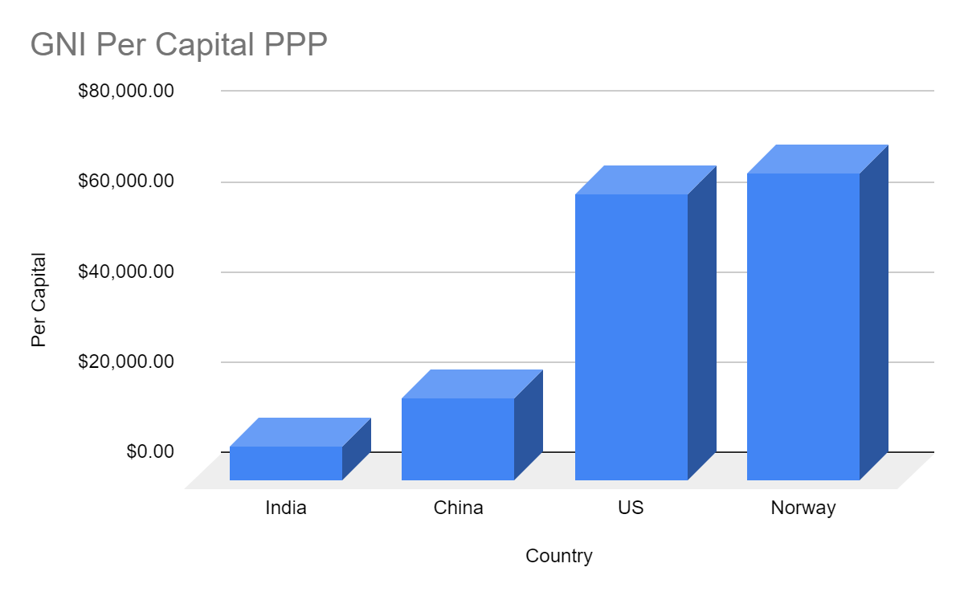

Because of low per capita income, people are very sensitive to price while making a buying decision. To make electric vehicles more accessible and affordable for mass consumers tesla has to slash its price by at least 50% to 60%

2. Collaboration with the Indian Government.

* Tesla can also take the benefit and support the Indian government in their make in India initiative. It will help both teslas as well as the Indian government. Once the Gigafactory is established in India it will help Tesla in reducing its manufacturing cost tremendously as the labor cost in India is much cheaper than the US or any other developed country. The Indian government will also be benefited from this as it will not only boost the make in India initiative but also create jobs for Indians.

3. Tesla should build a GigaFactory in India as China.

* Tesla is to build a Gigafactory in India which is something similar to what Tesla did in China by building Gigafactory in China

4. Make an affordable car.

* As mentioned earlier, India is a highly price sensitive market and also 22% weightage is given to the cost of purchasing an electric vehicle. Tesla needs to place its product smartly. Currently, in India, there is not much competition in the electric vehicle segment so Tesla must take the first big lead in the segment. Tesla will face competition from existing traditional automakers in India which includes Tata Motors, Maruti Suzuki, Hyundai, Mahindra & Mahindra, etc. Tata already launched its affordable Tata Nexon EV.
* **Cut down prices by doing this** -

The Indian market is not prepared for autonomous vehicles, the driving and traffic rules in India are on the softer side, also the road infrastructure is not adequate for the self-driving feature to work safely. Tesla can cut down on such features which are not suitable for Indian conditions and will not provide additional value to the customer and by cutting this feature down it can save a lot of costs which will eventually help in bringing the end purchase cost.

5. Create a charging Infrastructure.

* This is also a very important issue that Tesla needs to address in India. They have to make and spread the charging station network across different states in India. Tesla can join hands with the Indian government under their Faster Adoption and Manufacturing of (Hybrid) and Electric Vehicle (FAME) scheme which Will allow Tesla to spread its charging network rapidly and at a minimum cost. This will encourage Indians to shift towards EV.